<https://www.youtube.com/watch?v=BfKanl1aSG0&list=PLblh5JKOoLUKxzEP5HA2d-Li7IJkHfXSe&index=3>

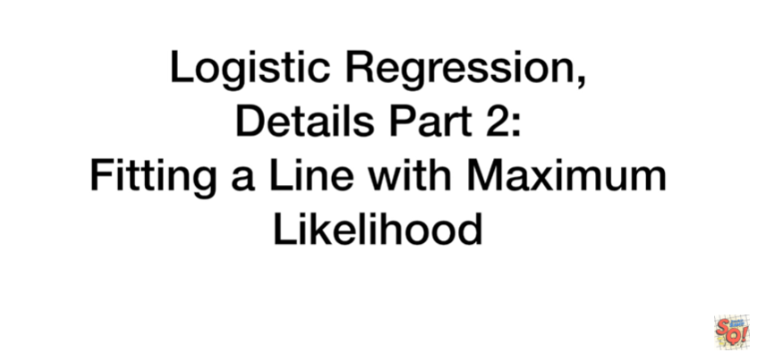

Today we're gonna follow up on our series of videos on logistic regression.

This time we're going to talk about fitting a line using maximum likelihood.

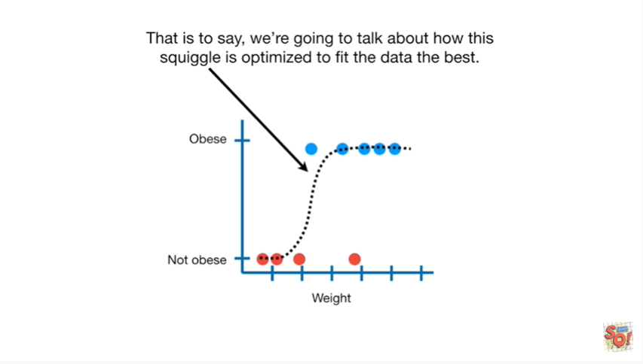

That is to say we're going to talk about how this squiggle is optimized to fit the data the best.

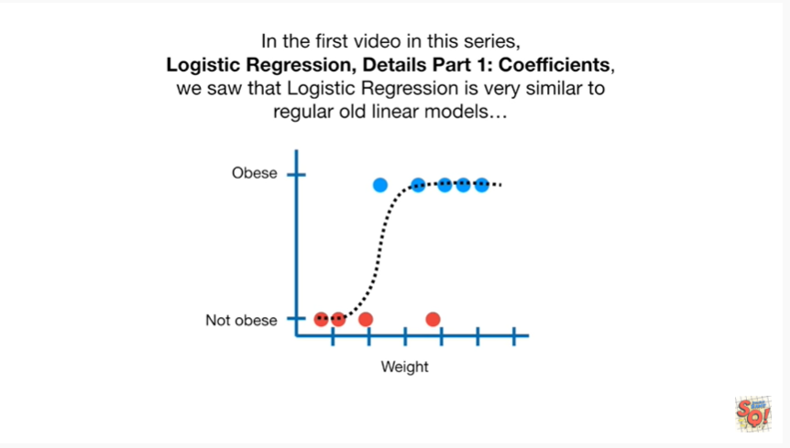

In the first video in this series logistic regression details part 1 coefficients, we saw that logistic regression is very similar to regular old linear models.

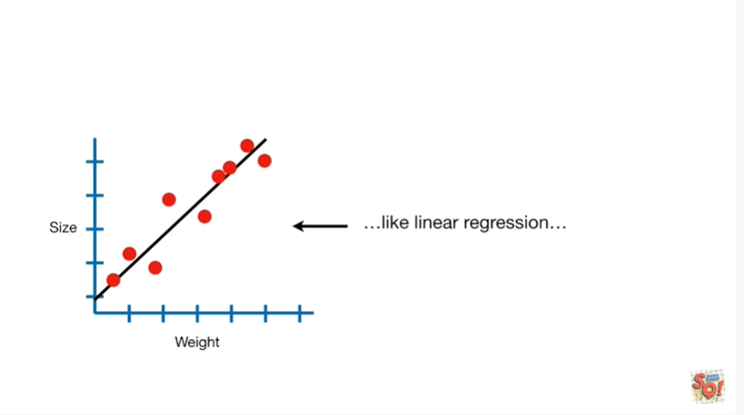

Like linear regression,

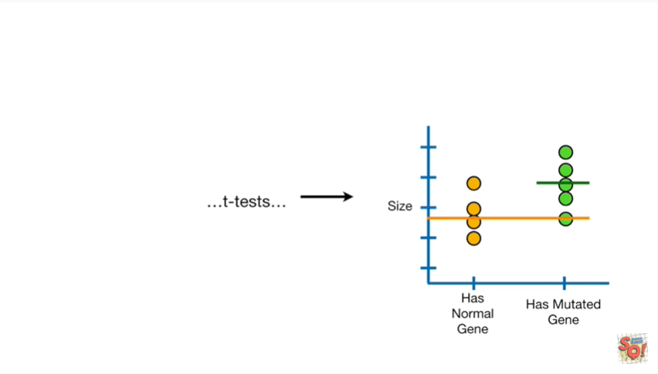

t-tests

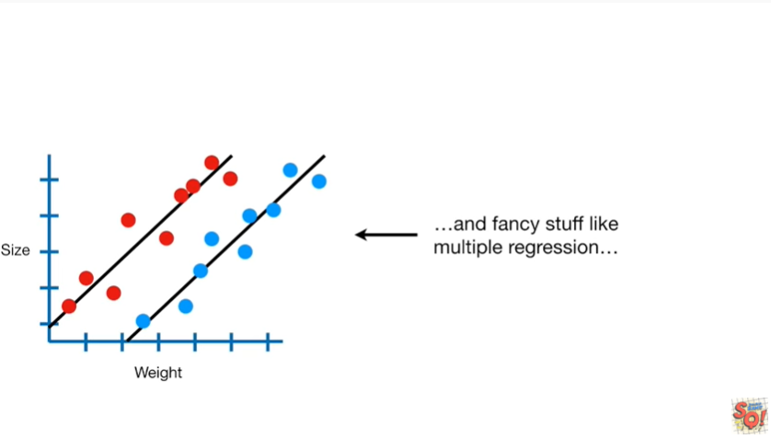

and fancy stuff like multiple regression

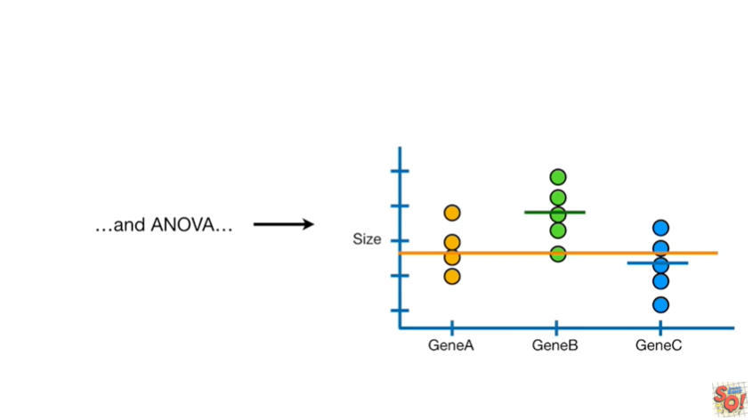

and ANOVA.

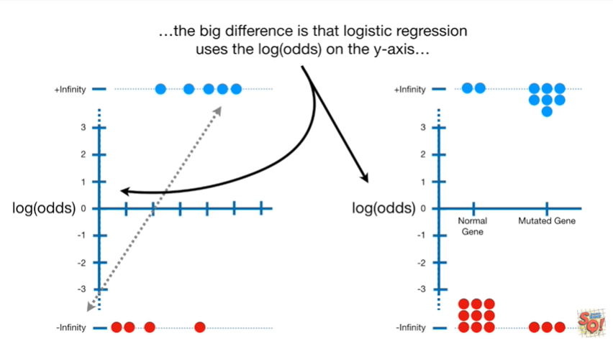

The big difference is that logistic regression uses the log odds on the y-axis.

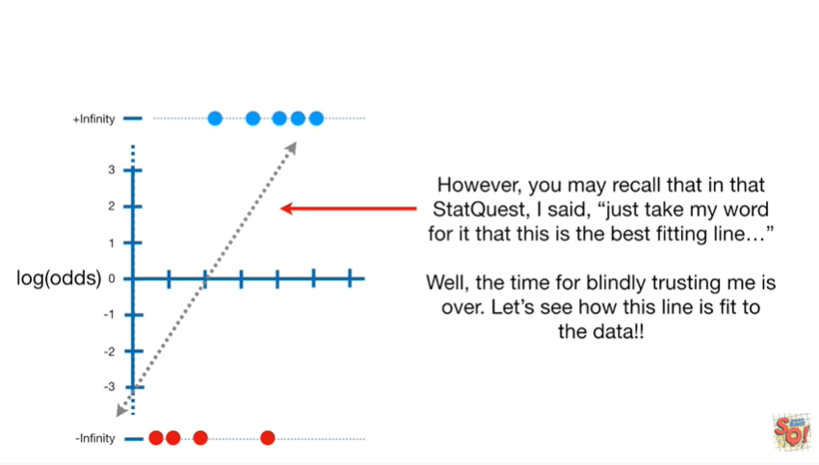

However you may recall that in that stat quest I said just take my word for it that this is the best fitting line.

Well the time for blindly trusting me is over let's see how this line is fit to the data.

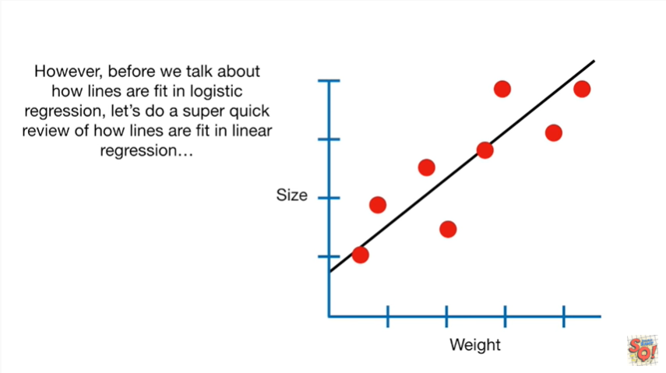

However before we talk about how lines are fit in logistic regression let's do a super quick review of how lines are fit in linear regression.

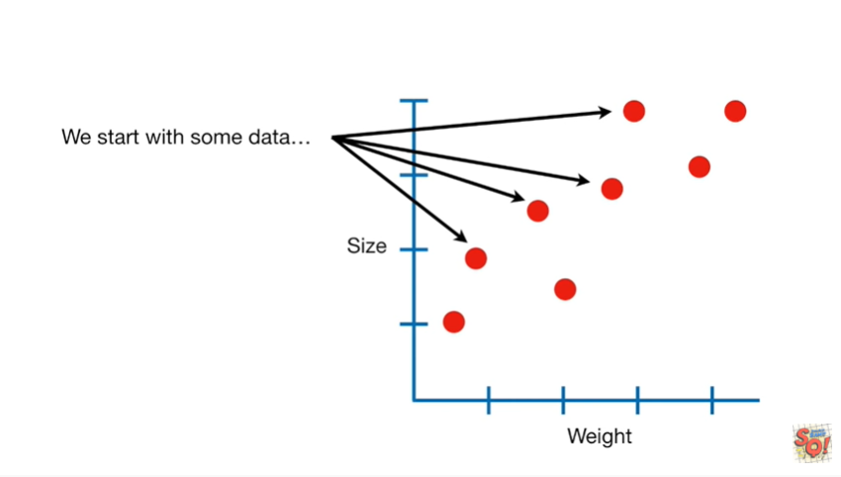

We start with some data

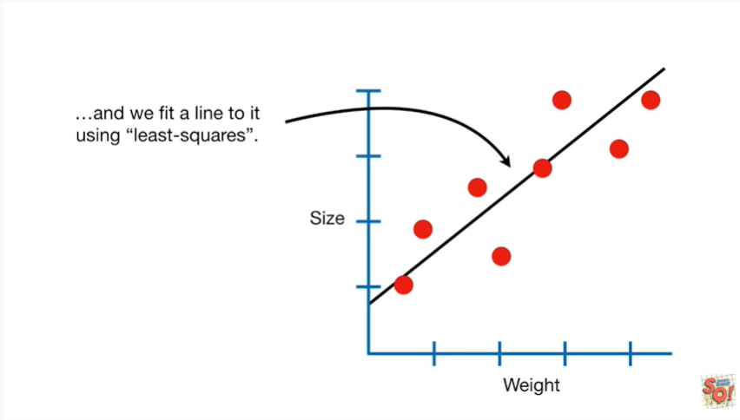

and we fit a line to it using least squares.

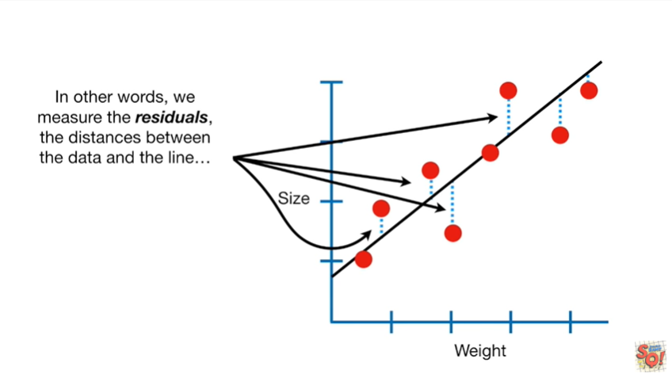

In other words we measured the residuals the distances between the data and the line

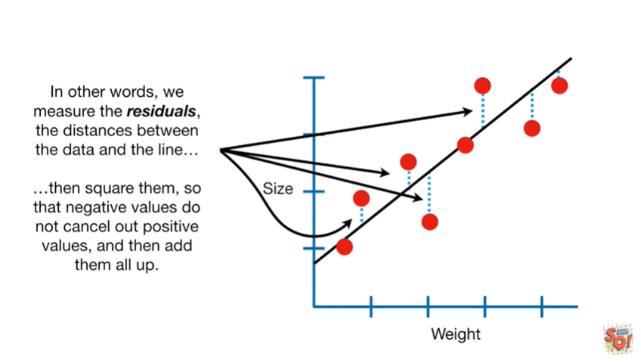

then square them so that negative values do not cancel out positive values and then add them all up.

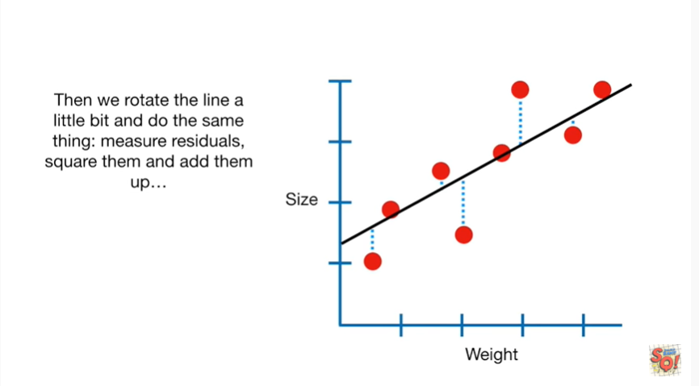

Then we rotate the line a little bit and do the same thing.

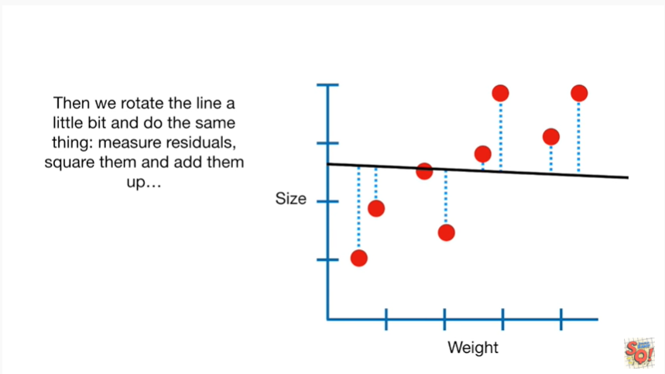

Measure the residuals, square them and add them up.

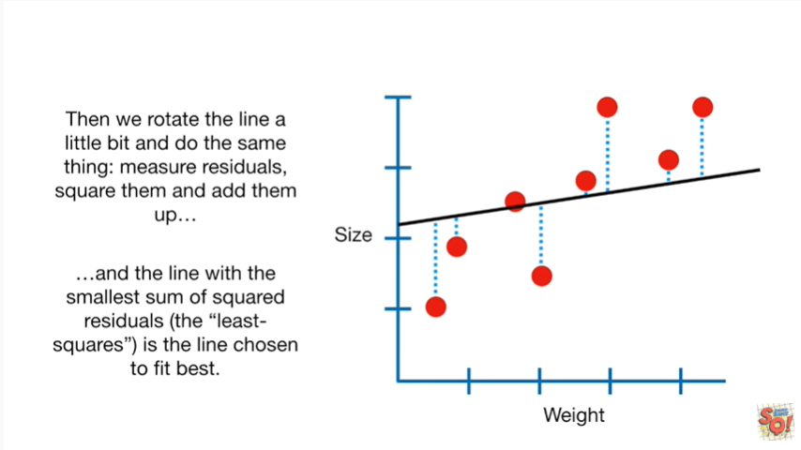

In the line with the smallest sum of squared residuals the least squares is the line chosen to fit best.

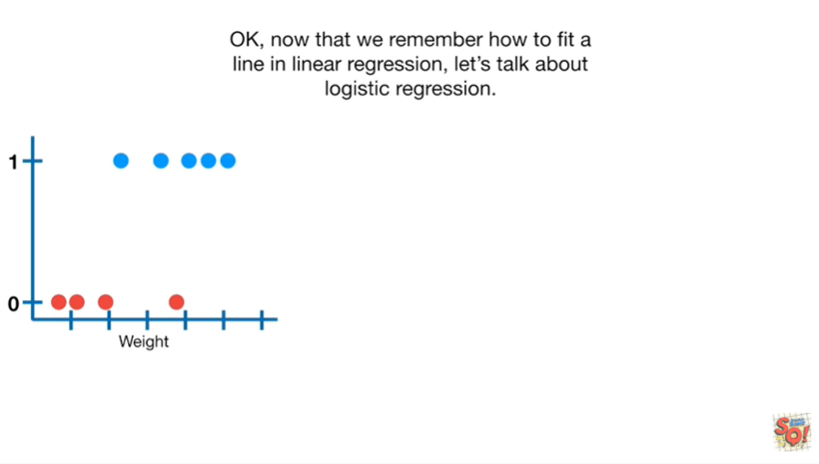

Okay now that we remember how to fit a line in linear regression, let's talk about logistic regression.

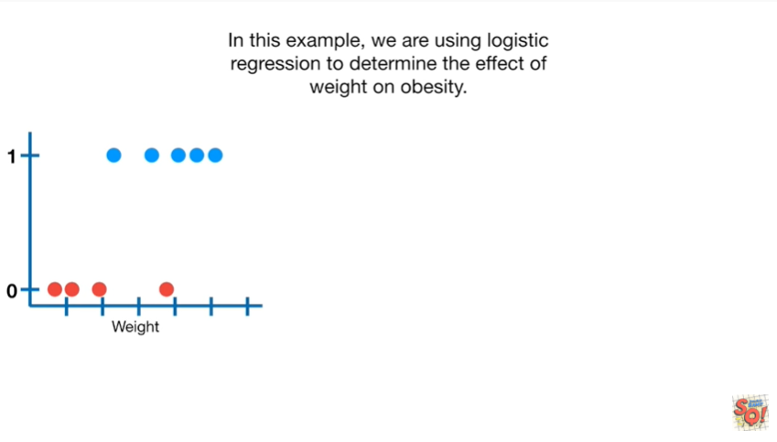

In this example we are using logistic regression to determine the effect of weight on obesity.

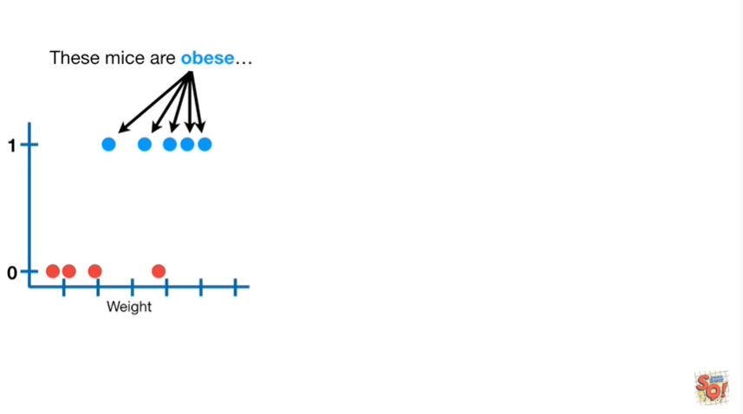

These mice are obese

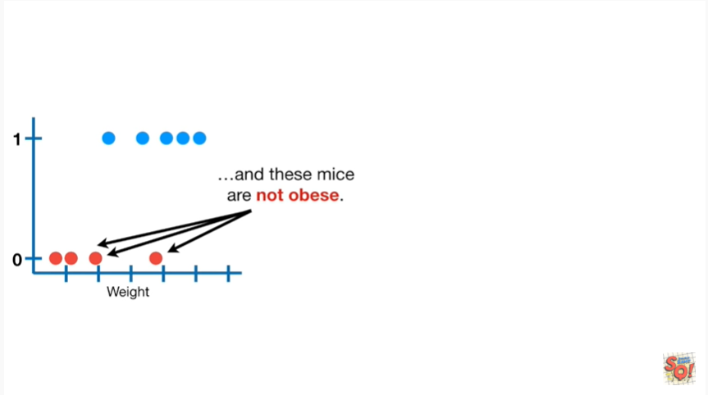

and these mice are not obese.

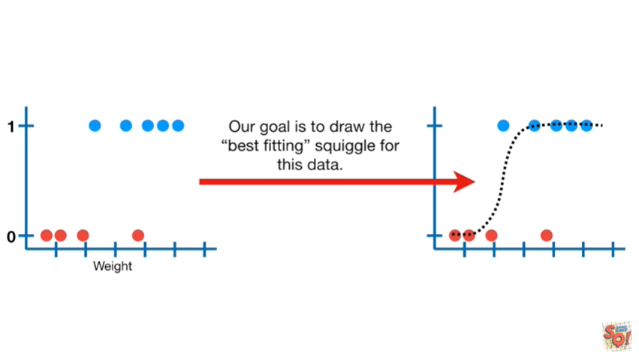

Our goal is to draw the best fitting squiggle for this data.

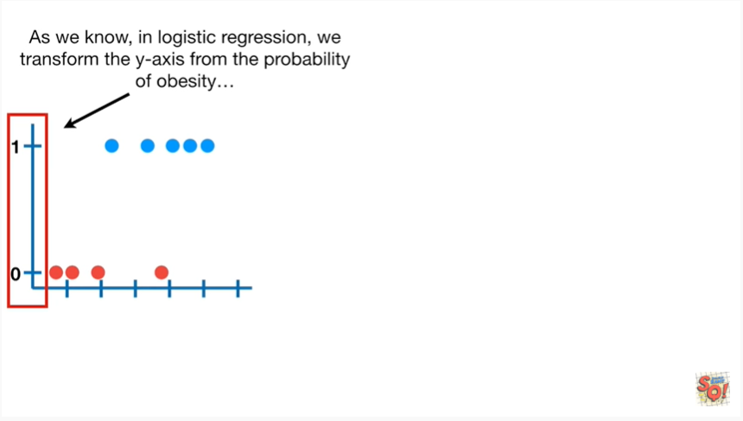

As we know in logistic regression we transform the y axis from the probability of obesity

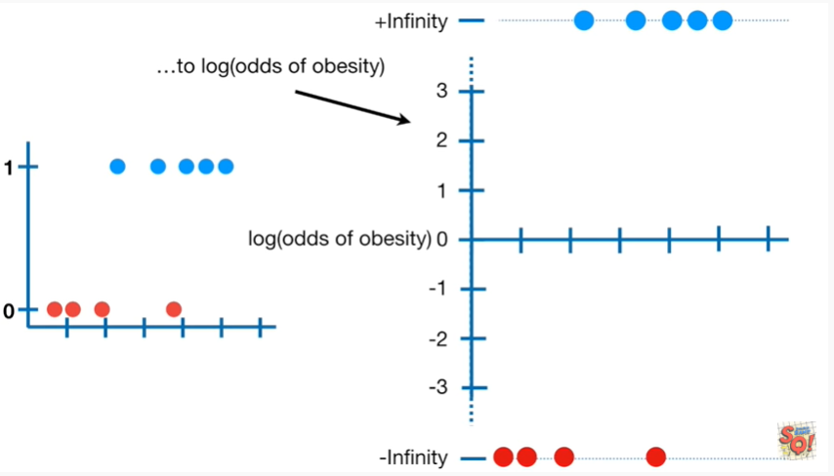

to the log odds of obesity.

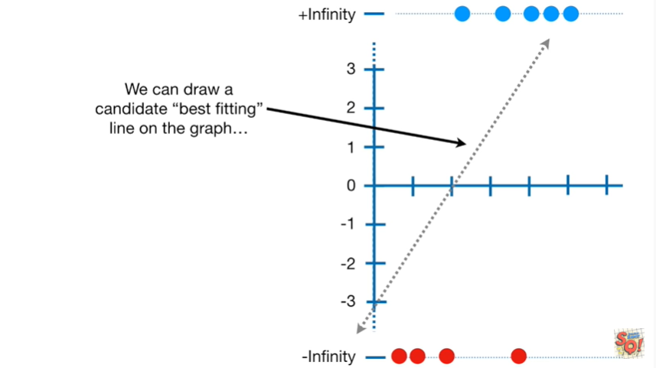

We can draw a candidate best fitting line on the graph.

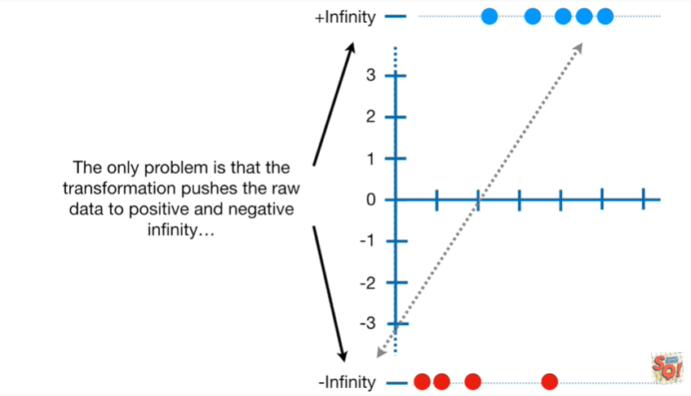

The only problem is that the transformation pushes the raw data to positive and negative infinity.

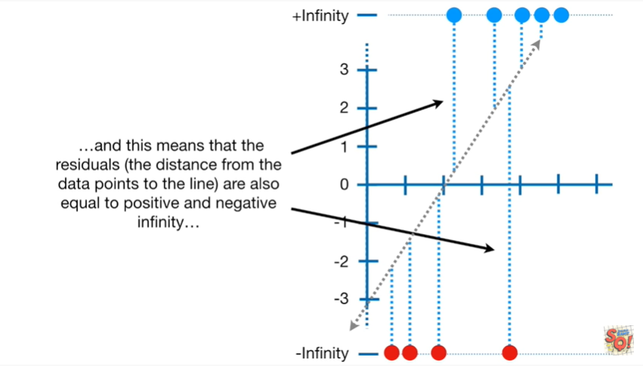

And this means that the residuals the distance from the data points to the line are also equal to positive and negative infinity.

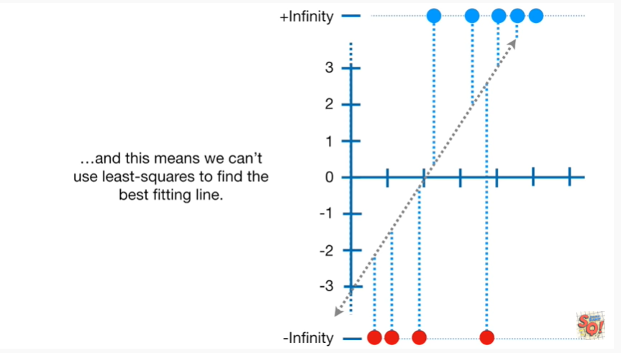

And this means we can't use least squares to find the best fitting line.

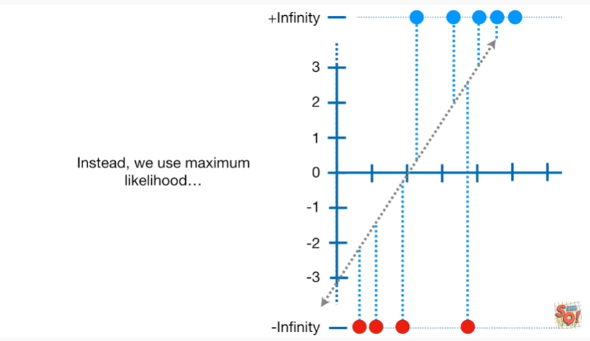

Instead we use maximum likelihood.

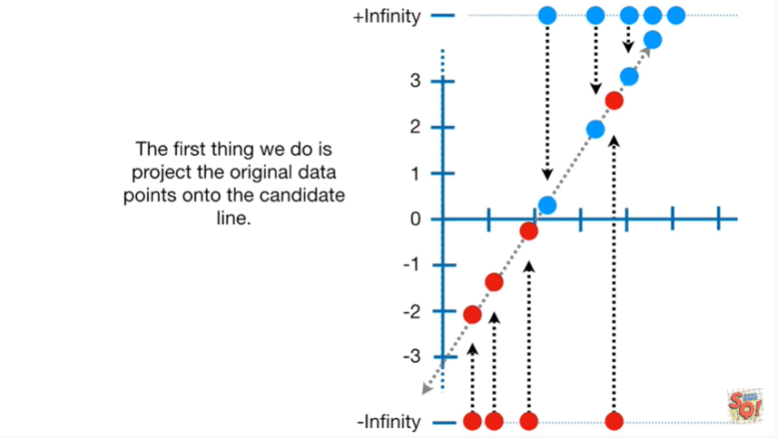

The first thing we do is project the original data points onto the candidate line.

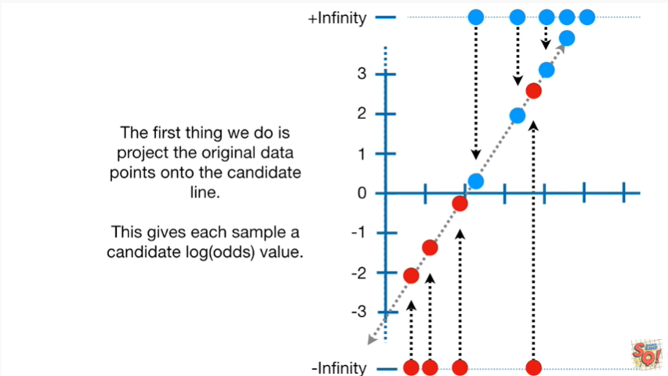

This gives each sample a candidate log-odds value.

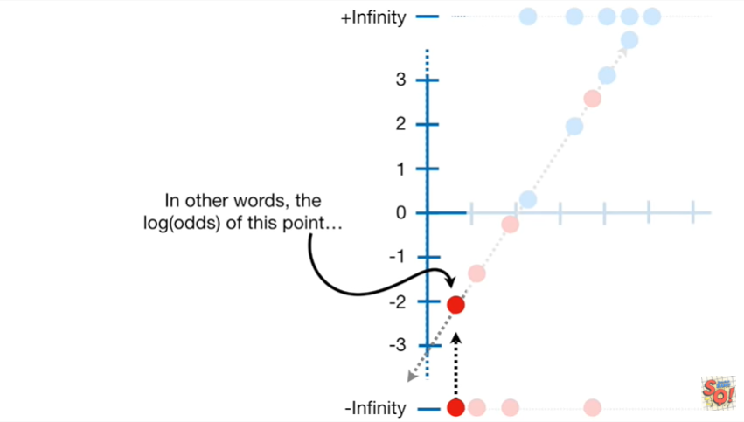

In other words the log odds of this point

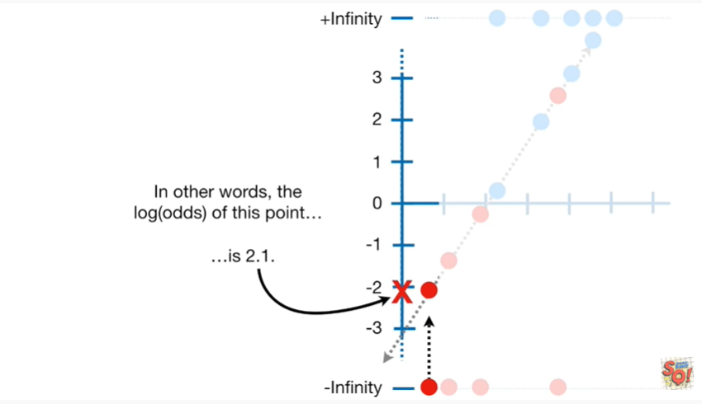

is two point one.

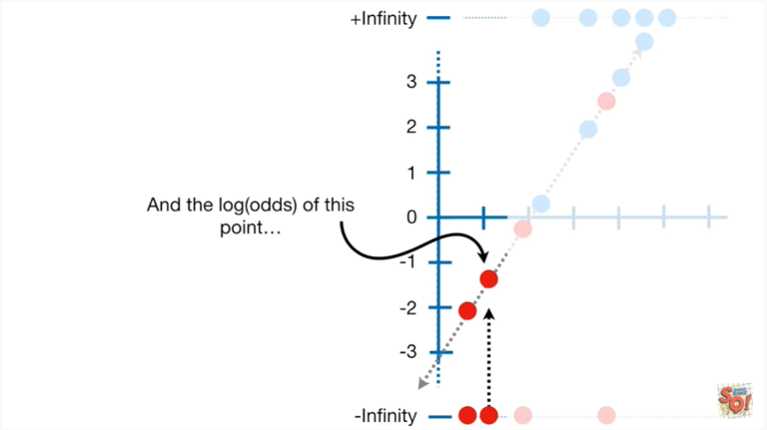

And the log odds of this point

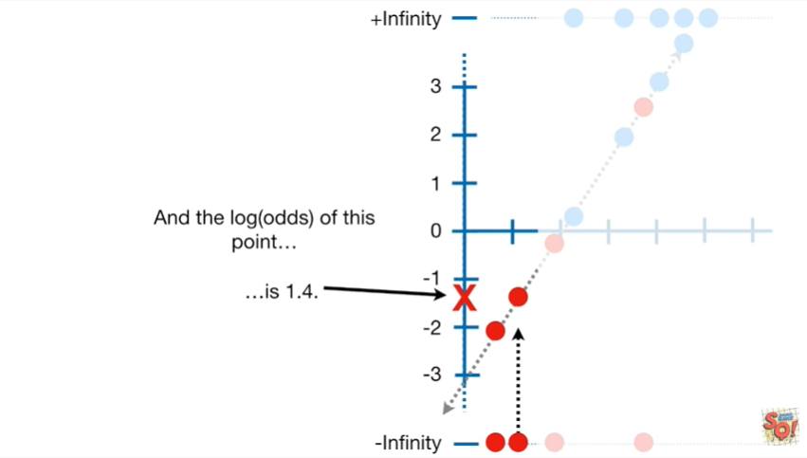

is one point four.

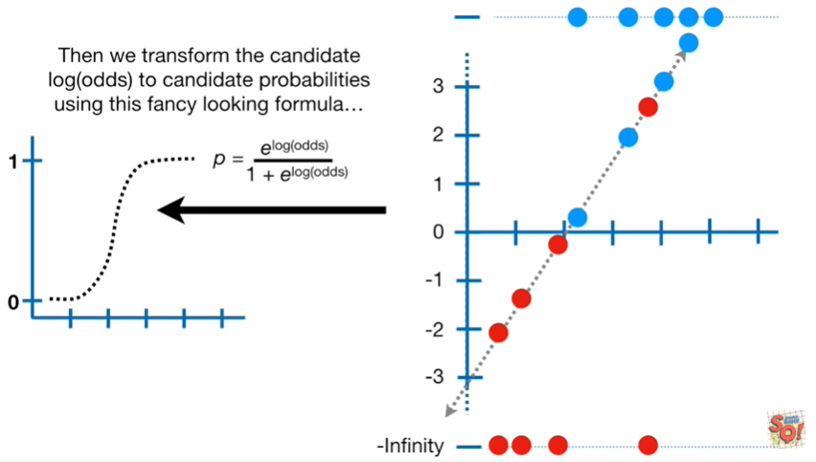

Then we transform the candidate log odds to candidate probabilities using this fancy looking formula.

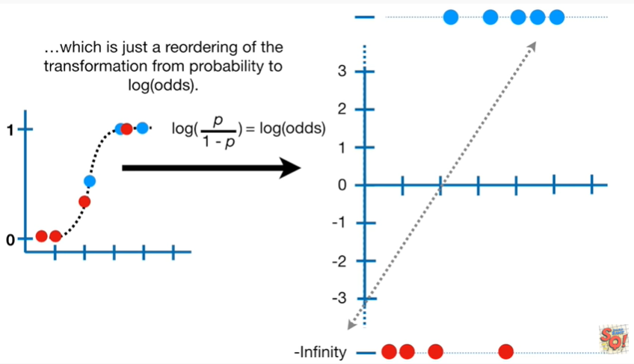

Which is just a reordering of the transformation from probability to log odds.

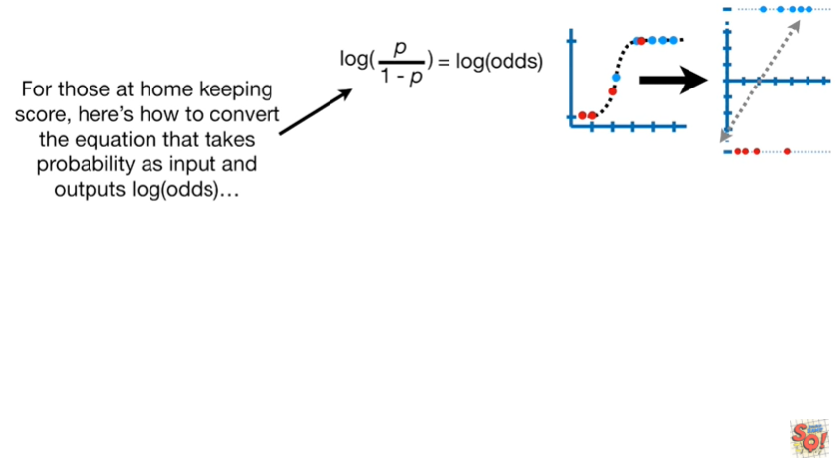

For those at home keeping score here's how to convert the equation that takes probability as input and outputs log odds

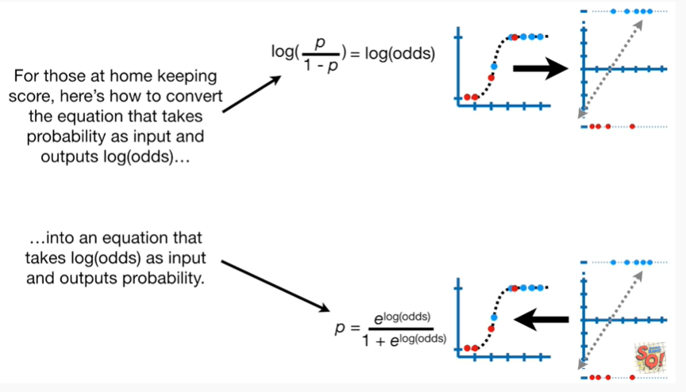

into an equation that takes log odds as input and outputs probability.

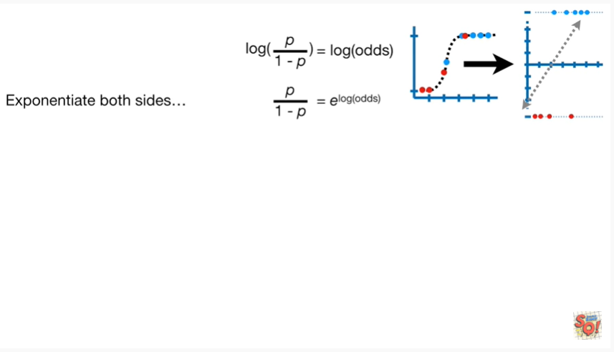

First we exponentiate both sides.

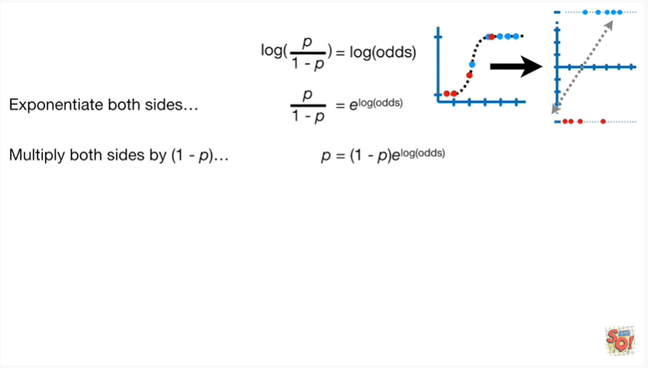

Then we multiply both sides by one minus P.

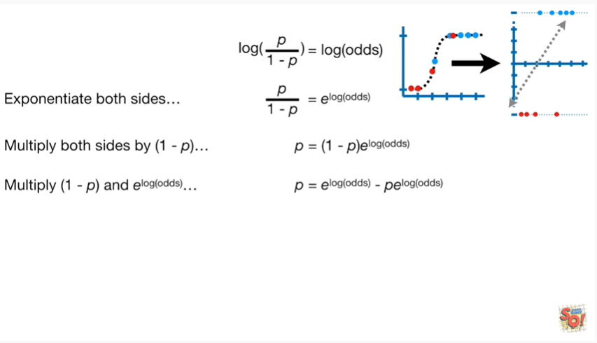

And then multiply 1 minus P and E to the log odds.

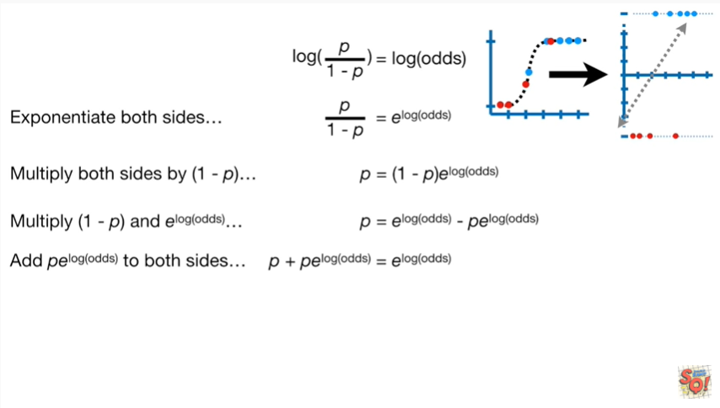

Then we add P times e to the log odds to both sides.

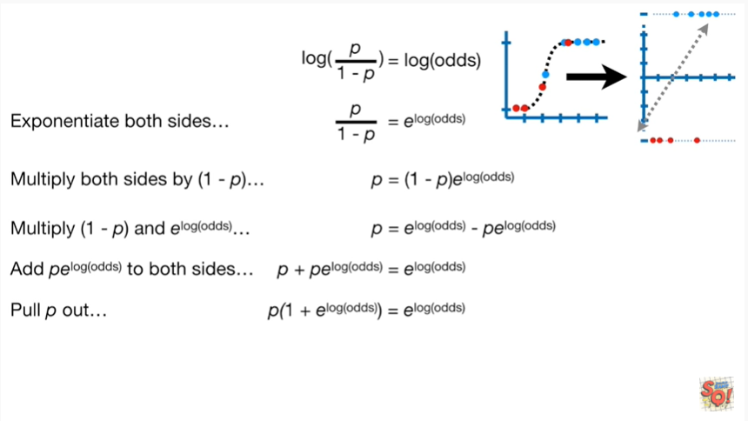

Then we pull P out on the left side of the equation.

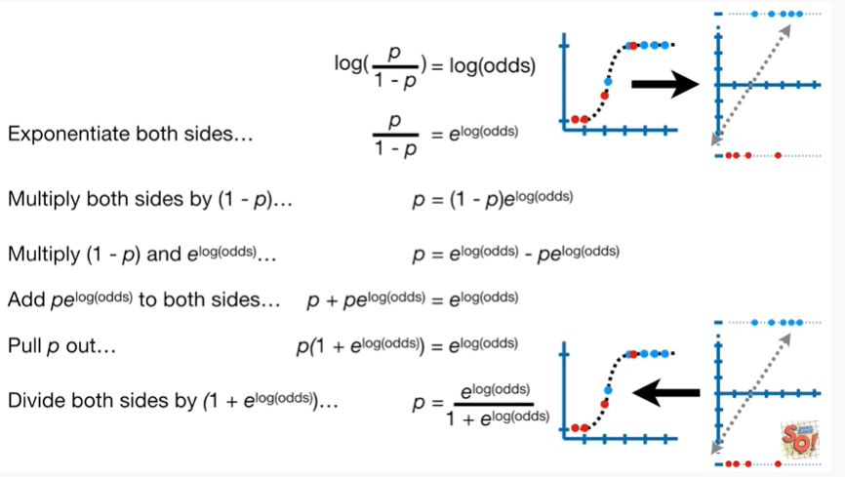

Lastly we divide both sides by 1 plus e to the log odds.

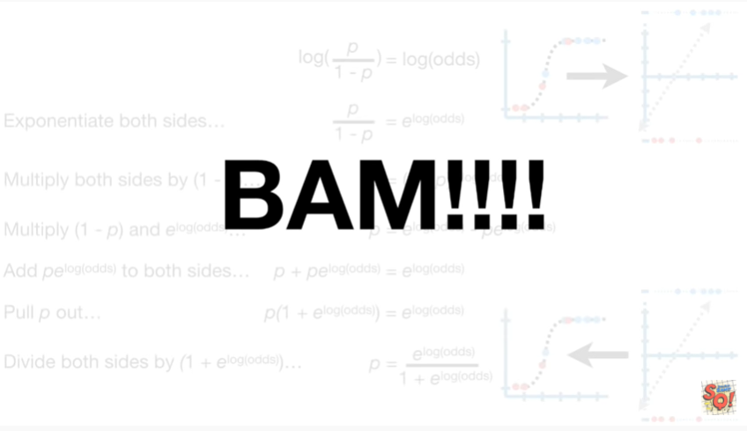

BAM.

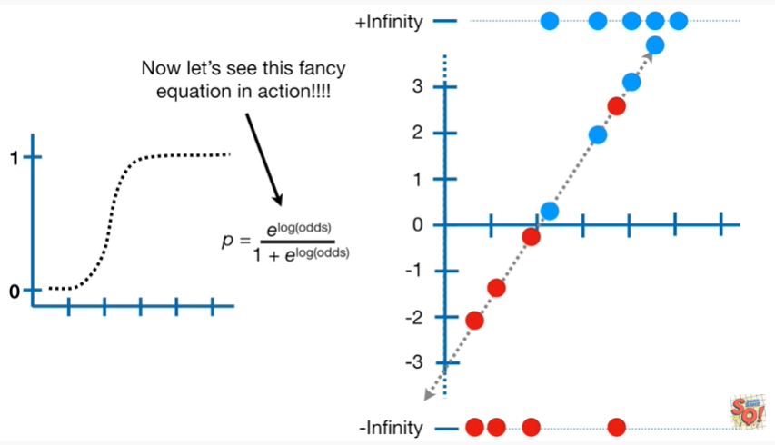

Now let's see this fancy equation in action.

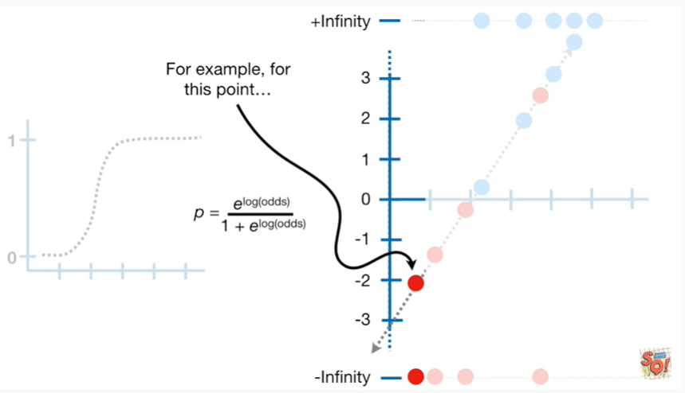

For example for this point

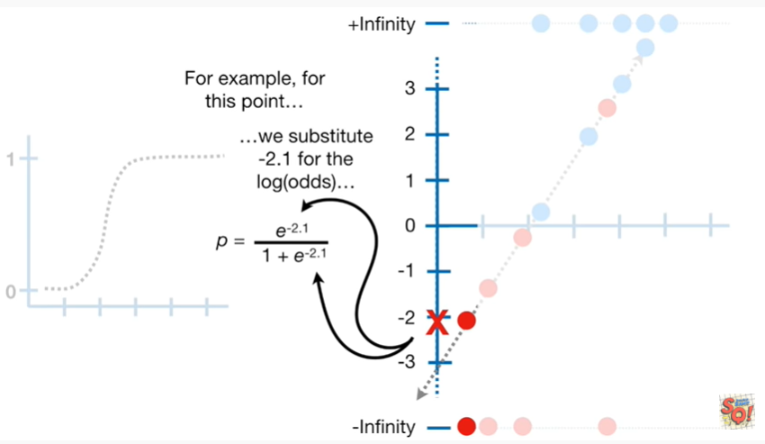

we substitute negative 2.1 for the log odds

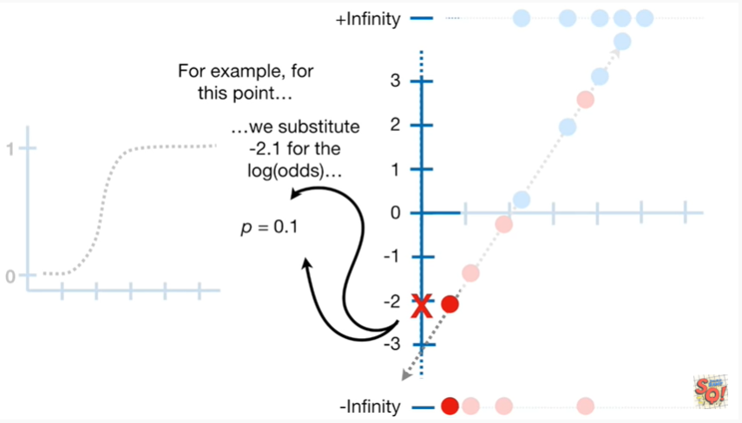

and that gives us P equals 0.1.

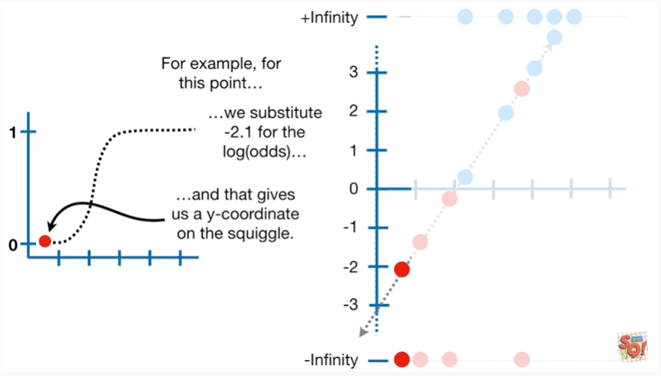

And that gives us a y-coordinate on the squiggle.

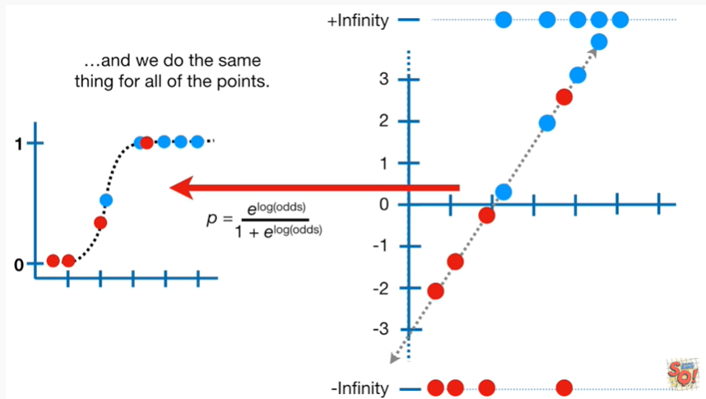

And we do the same thing for all of the points.

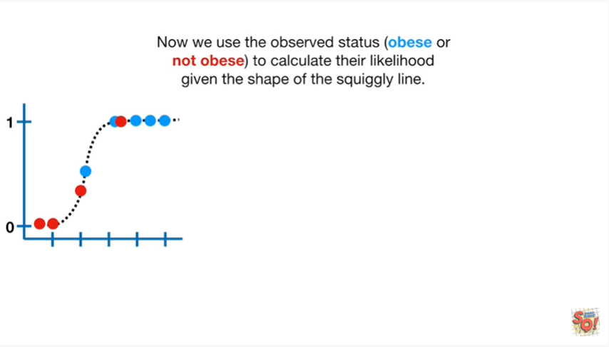

Now we use the observed status obese or not obese to calculate their likelihood given the shape of the squiggly line.

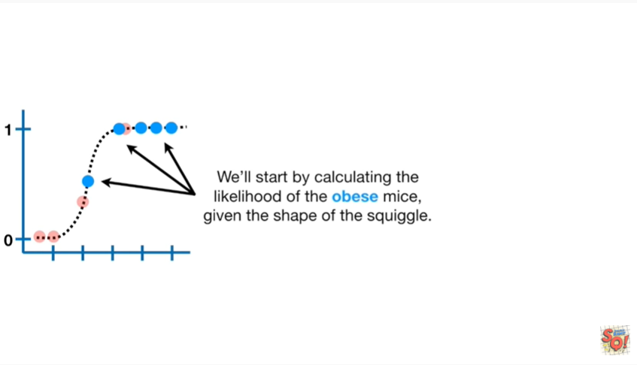

We'll start by calculating the likelihood of the obese mice given the shape of the squiggle.

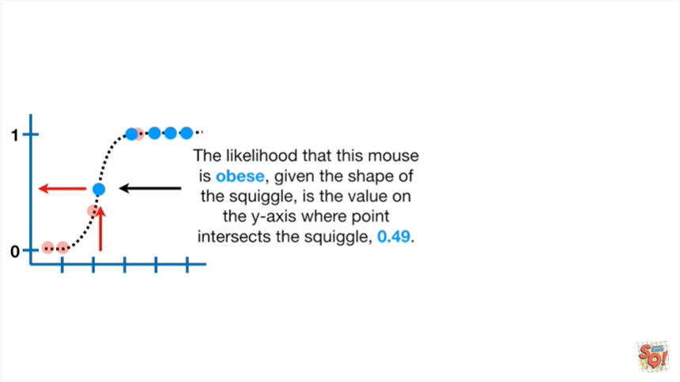

The likelihood that this Mouse is obese given the shape of the squiggle is the value on the y-axis where the point intersects the squiggle 0.49.

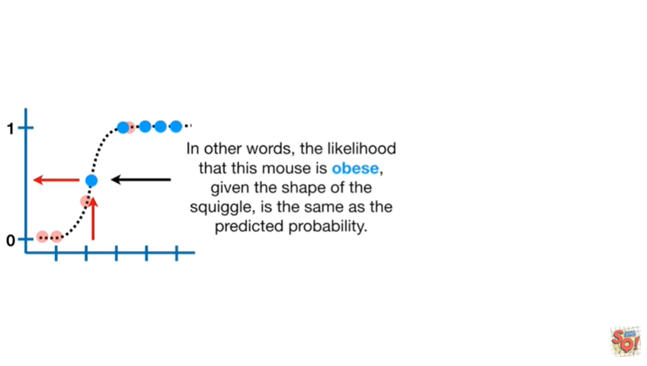

In other words the likelihood that this Mouse is obese given the shape of the squiggle is the same as the predicted probability.

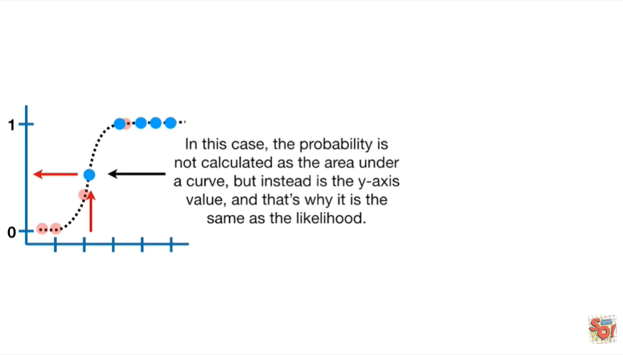

In this case the probability is not calculated as the area under a curve but instead is the y-axis value and that's why it's the same as the likelihood.

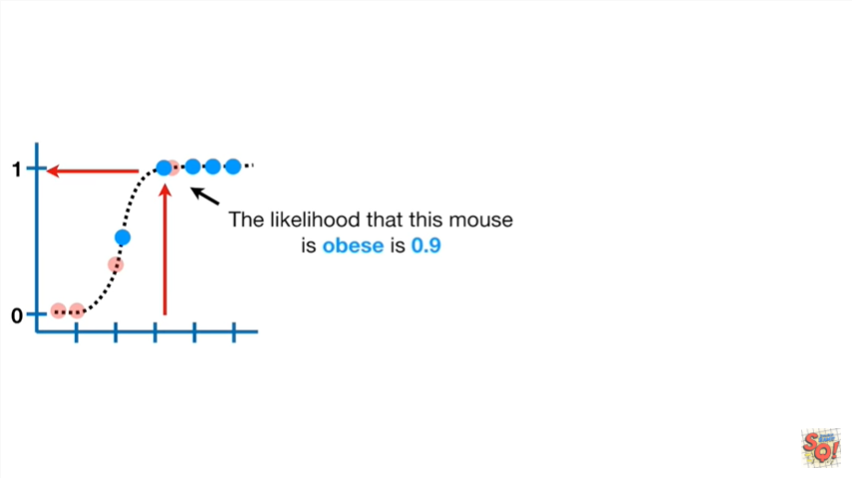

The likelihood that this Mouse's obese is 0.9.

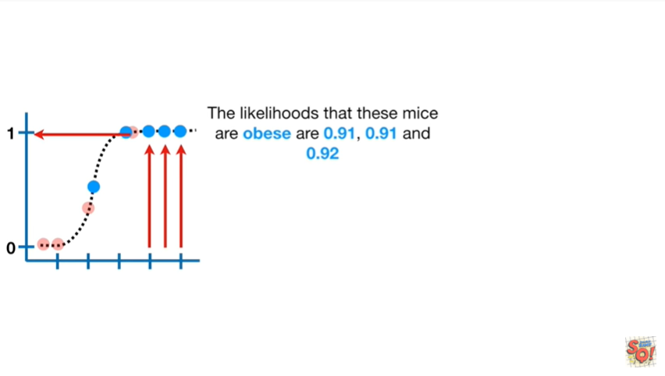

The likelihoods that these mice are obese are 0.91, 0.91 and 0.92.

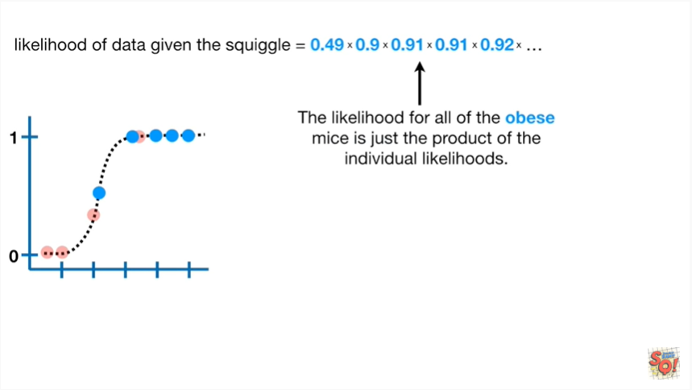

The likelihood for all of the obese mice is just the product of the individual likelihoods.

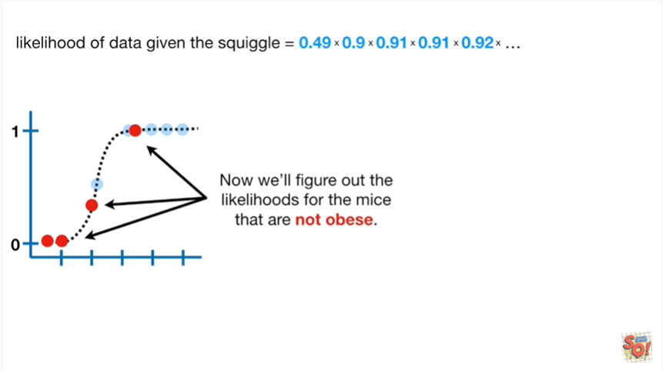

Now we'll figure out the likelihoods for the mice that are not obese.

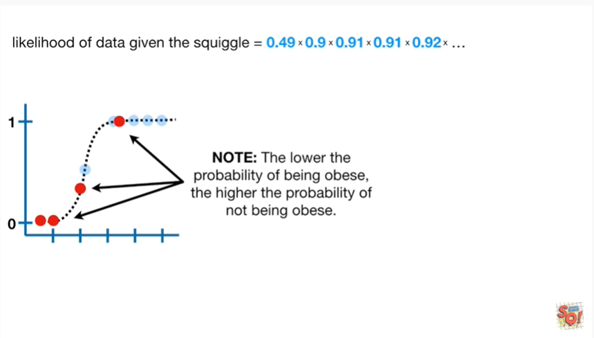

Note : the lower the probability of being obese the higher the probability of not being obese.

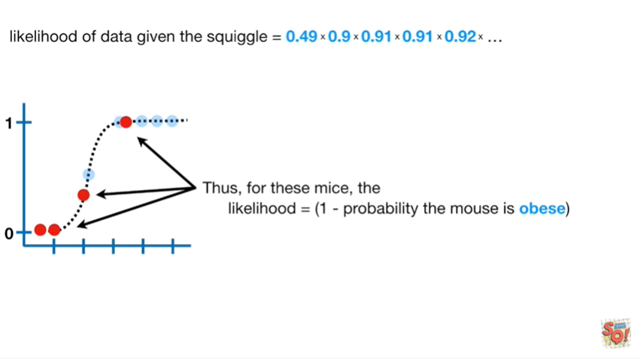

Thus for these mice the likelihood equals one minus the probability the mouse is obese.

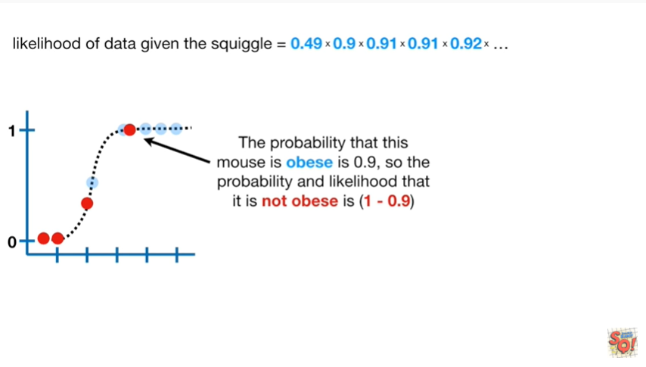

The probability that this Mouse is obese is 0.9 so the probability and likelihood that it is not obese is 1 minus 0.9.

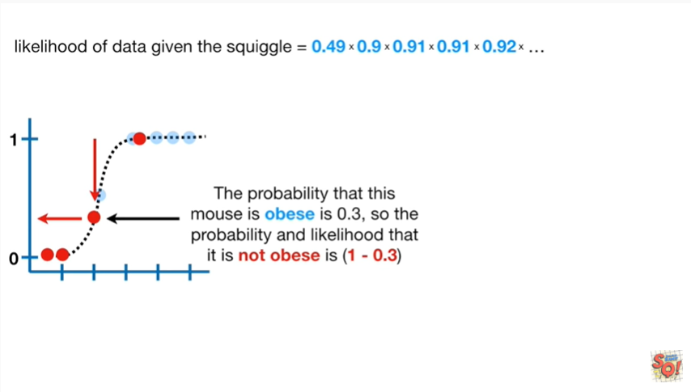

The probability that this Mouse is obese is 0.3, so the probability and likelihood that it is not obese is 1 minus 0.3.

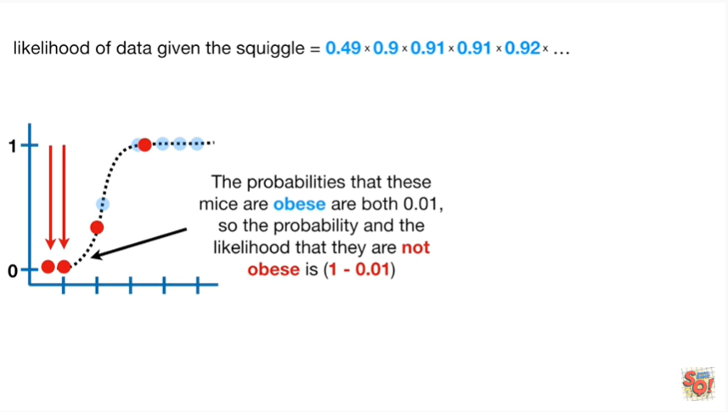

The probabilities that these mice are obese are both 0.01, so the probability and the likelihood that they are not obese is 1 minus 0.01.

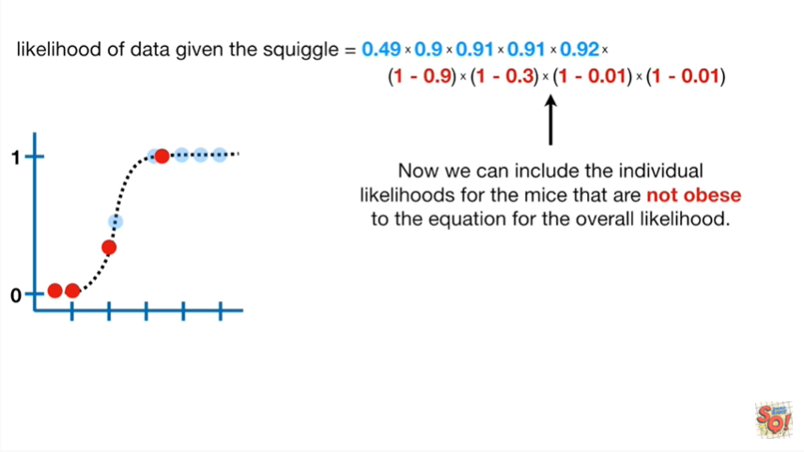

Now we can include the individual likelihoods for the mice that are not obese to the equation for the overall likelihood.

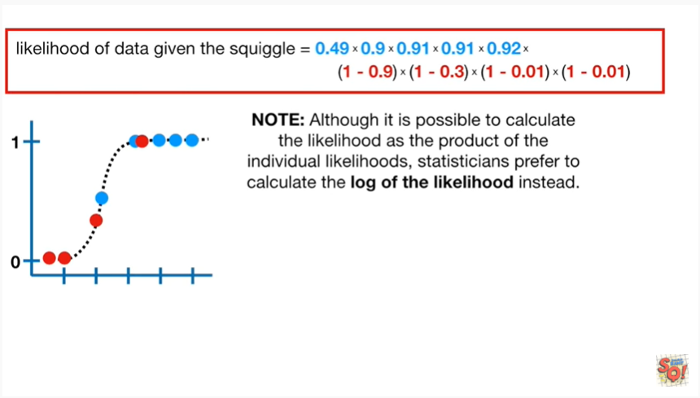

Note : although it is possible to calculate the likelihood as the product of the individual likelihoods, statisticians prefer to calculate the log of the likelihood instead.

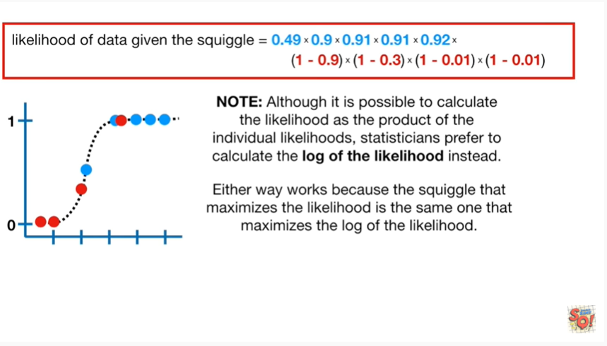

Either way works because the squiggle that maximizes the likelihood is the same one that maximizes the log of the likelihood.

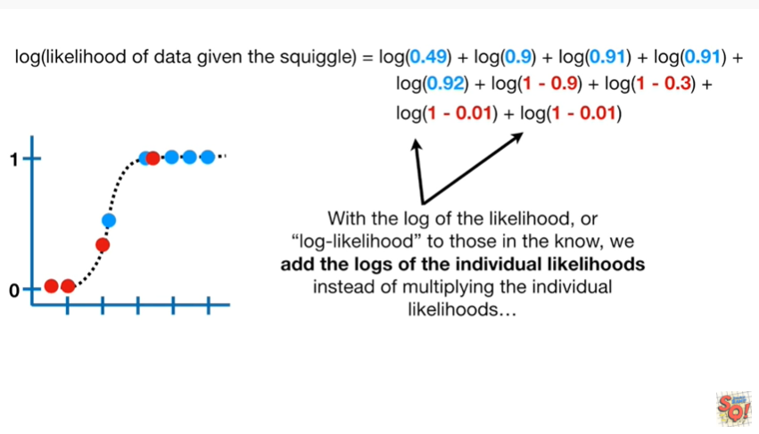

With the log of the likelihood or log-likelihood to those in the know we add the logs of the individual likelihoods instead of multiplying the individual likelihoods.

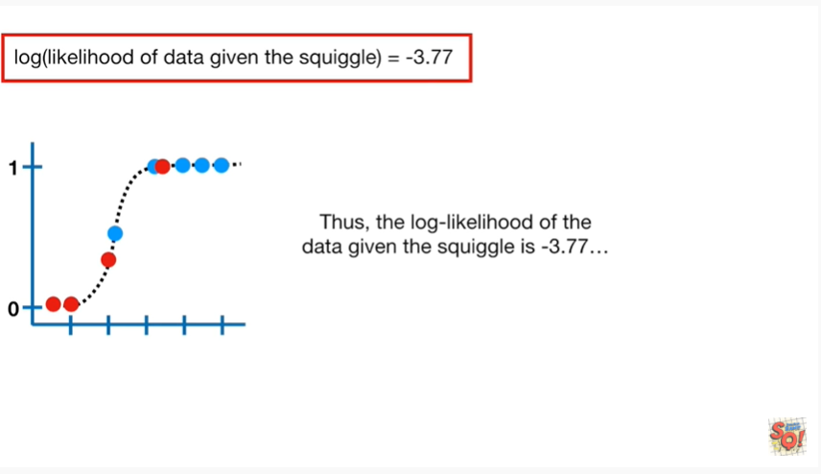

Thus the log likelihood of the data given the squiggle is negative three point seven seven.

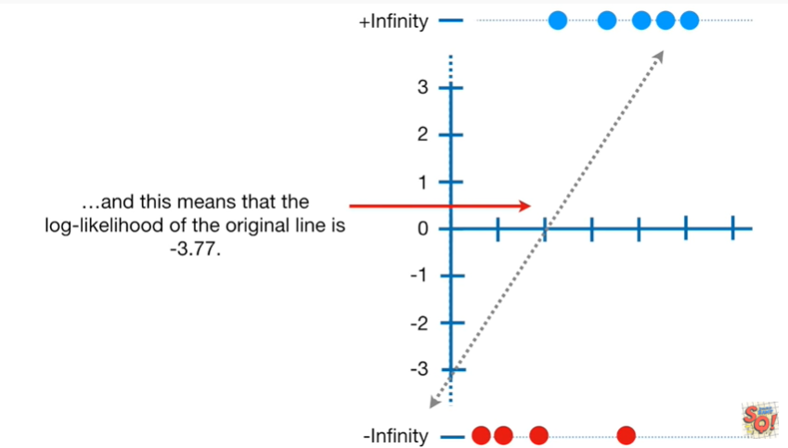

And this means that the log-likelihood of the original line is negative three point seven seven.

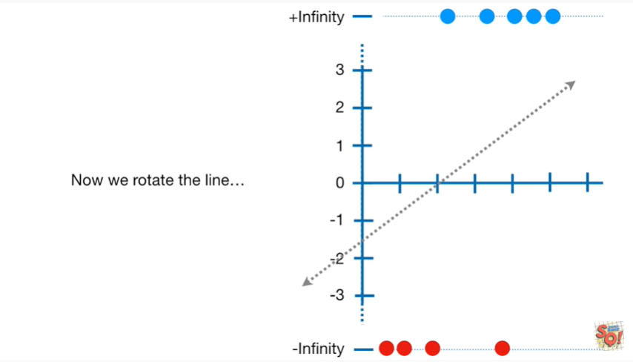

Now we rotate the line.

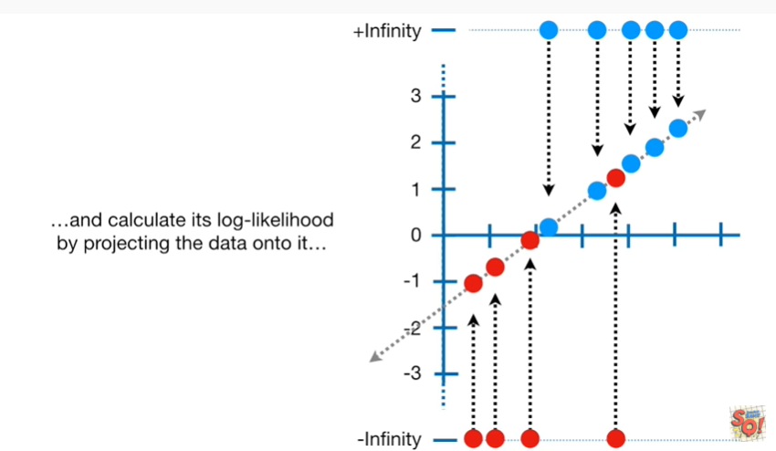

And calculate its log likelihood by projecting the data onto it.

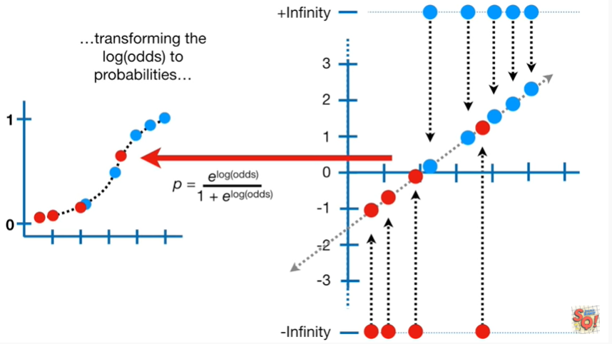

Transforming the log odds to probabilities

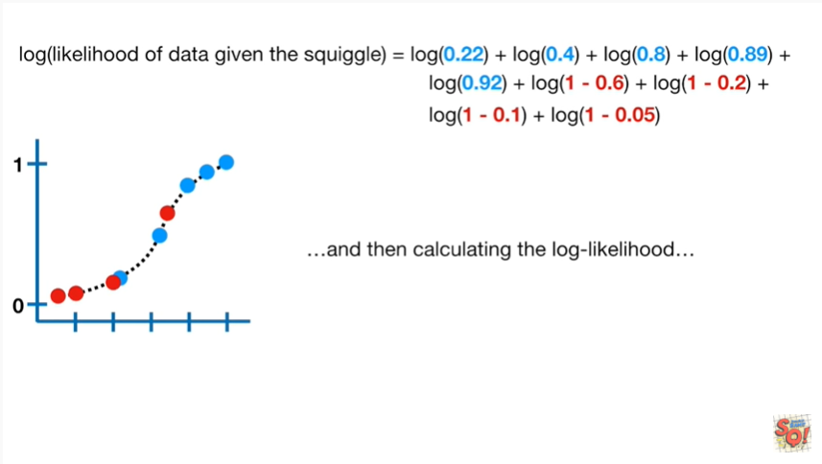

and then calculating the log likelihood

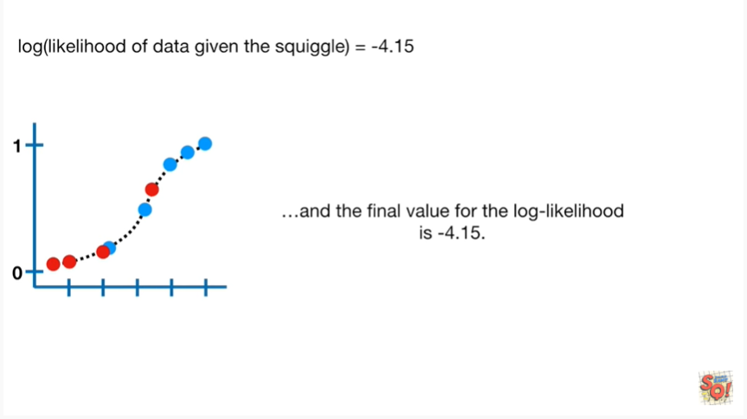

and the final value for the log likelihood is negative four point one five.

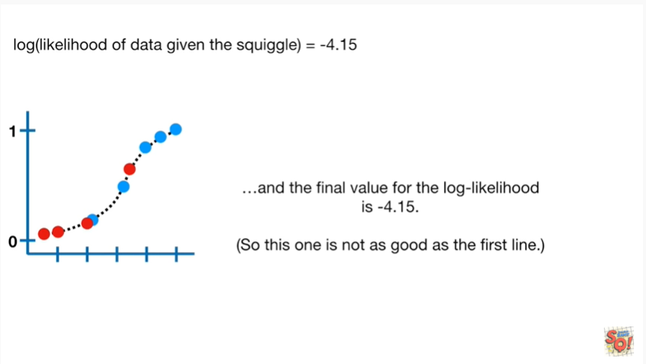

So this one is not as good as the first line.

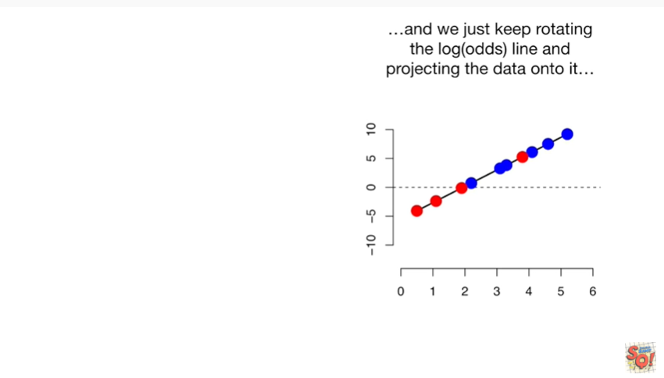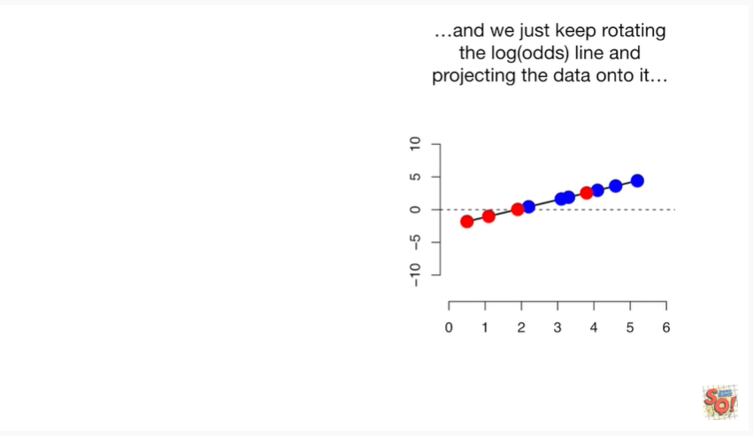

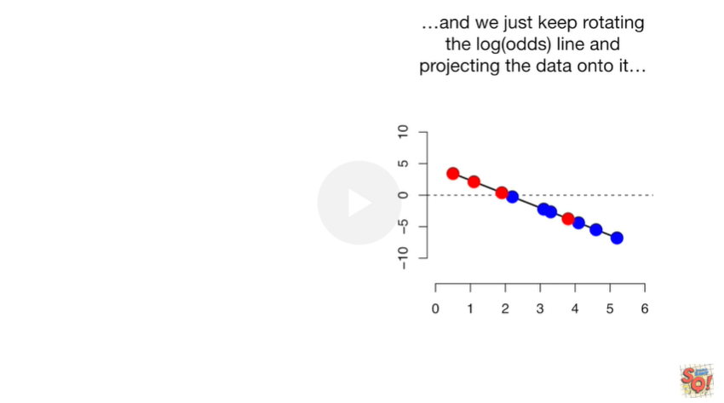

And we just keep rotating the log odds line and projecting the data onto it.

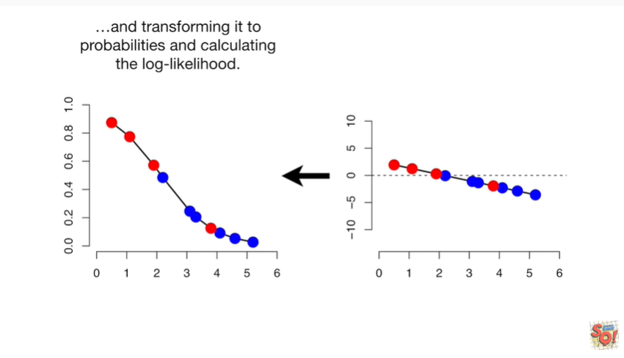

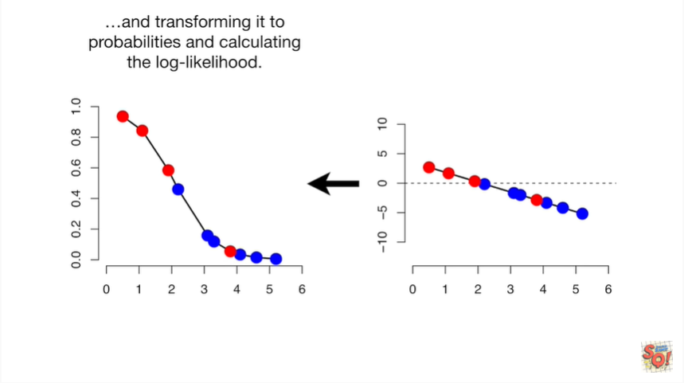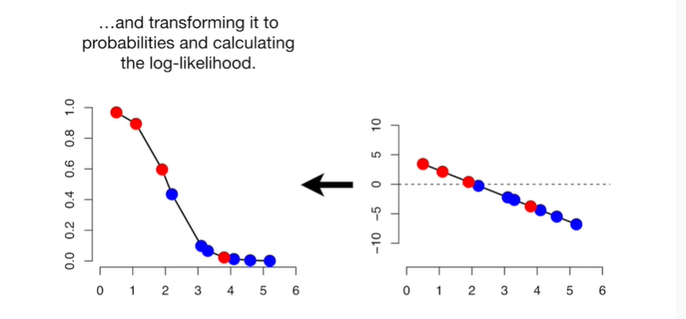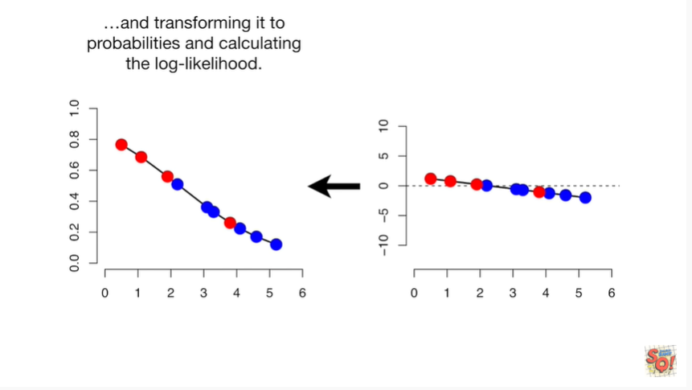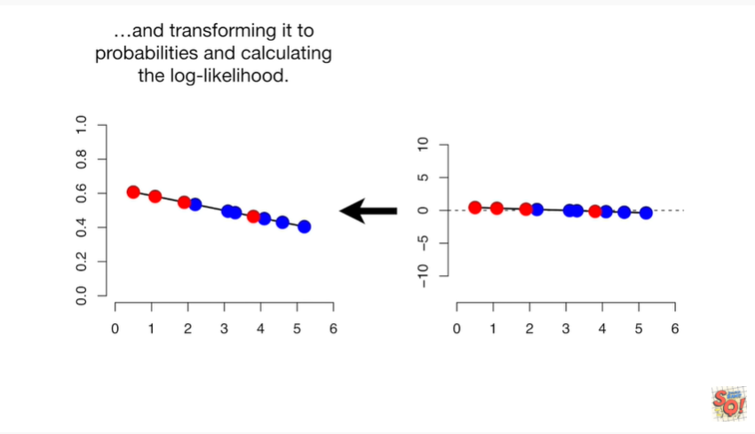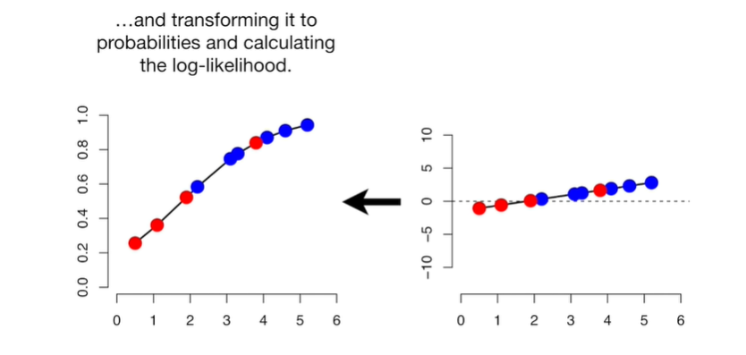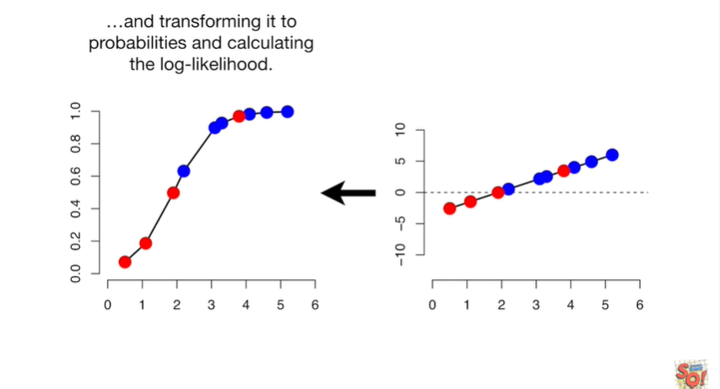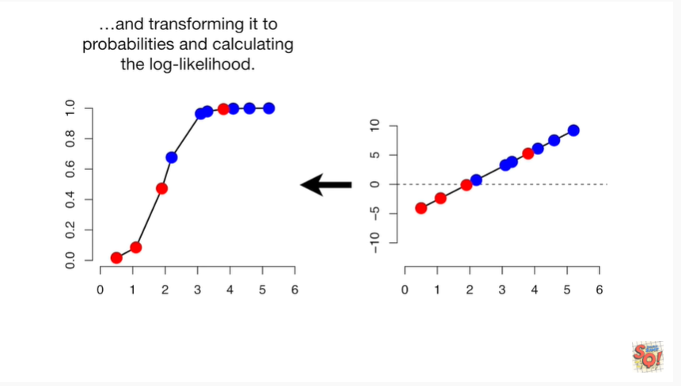

And then transforming it to probabilities in calculating the log-likelihood.

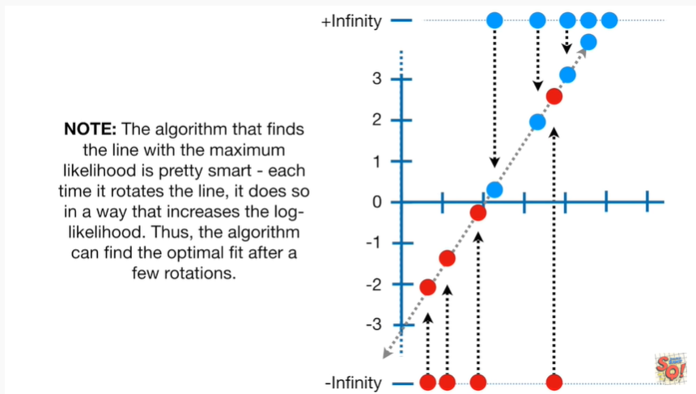

Note : the algorithm that finds the line with the maximum likelihood is pretty smart each time it rotates the line it does so in a way that increases the log likelihood.

Thus the algorithm can find the optimal fit after a few rotations.

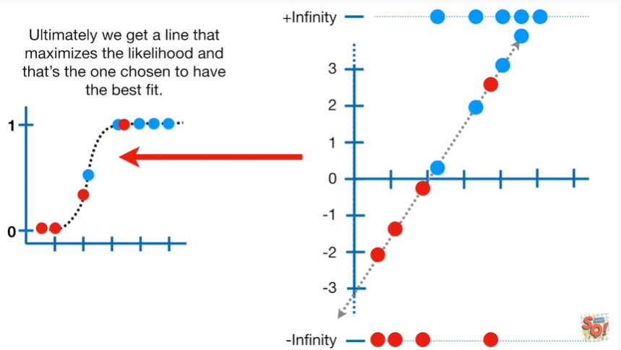

Ultimately we get a line that maximizes the likelihood and that's the one chosen to have the best fit.

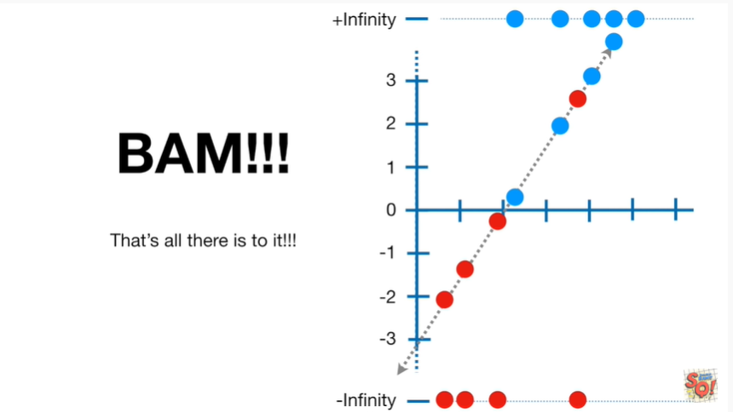

BAM !!!

That's all there is to it !!!

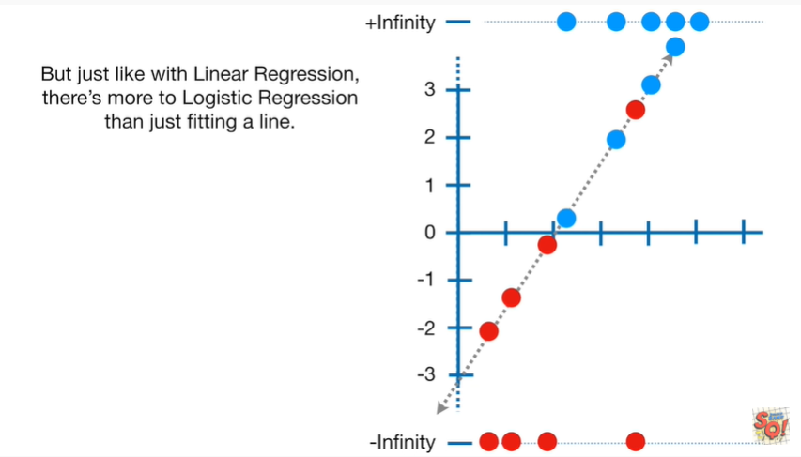

But just like with linear regression there's more to logistic regression than just fitting a line.

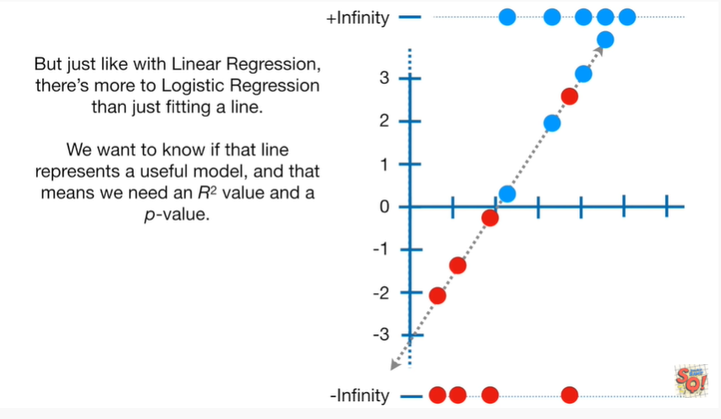

We want to know if that line represents a useful model and that means we need an r-squared value and a p-value .

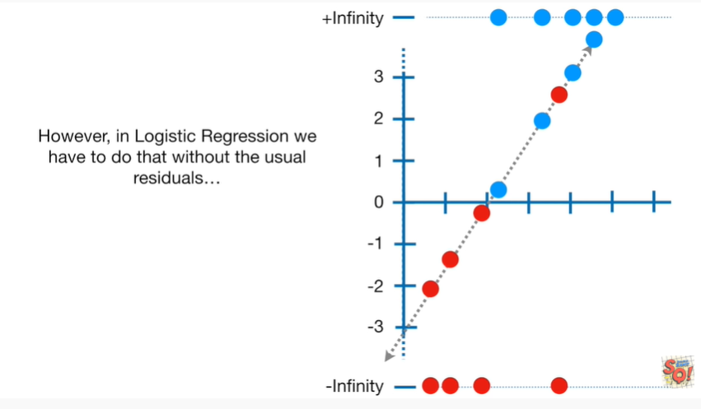

However in logistic regression we have to do that without the usual residuals.

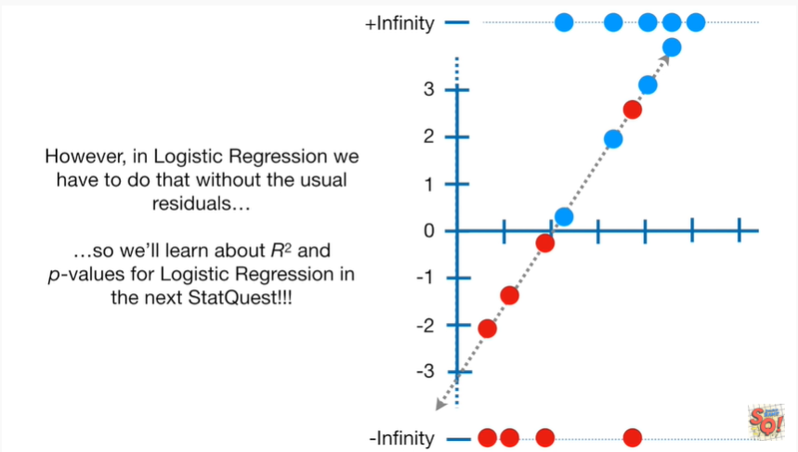

So we'll learn about r-squared and P values for logistic regression in the next stack quest.